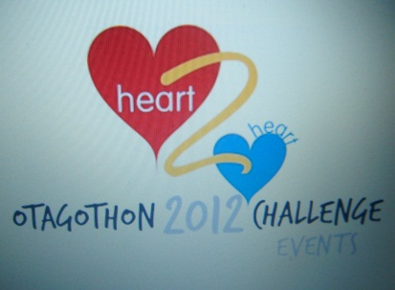
Heart 2 Heart is a phase IV cardiac rehabilitation class based in Alloa. Members of the group come from across Clackmannanshire. The Otagothon event was held on the evening of 13th of August 2012. Utilising the energy and the excitement of the Olympics we had an Olympic theme.
The evening started with an Olympic style warm up. Then the competitors divided into small groups and worked their way around the individual Olympic circuit. Spending 4 minutes at each of the stations the competitors’ competed in events challenging their strength, balance, co-ordination, whilst maintaining a moderate challenge on their cardio-respiratory challenge. Some examples include, shot put, basketball shooting and marathon challenge. The competitors kept a score sheet as they went round each of the stations.

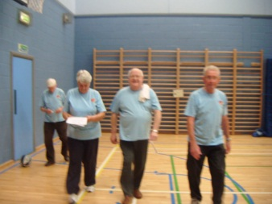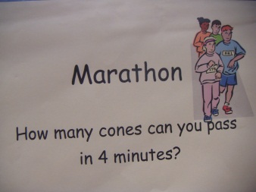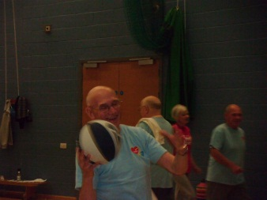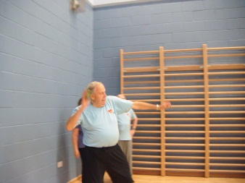

Following the individual events competitors submitted their score sheet and were divided into two groups for the basketball team event. The contest was very close, required skills in ball passing and shooting, in the end team A took the trophy! The evening slowed down into the cool down and Tai chi session and concluded with the award ceremony. The winners of the individual events won an Olympic goblet and the team event winner won a golden crunchy bar each. The names of the winners were also published in the Heart 2 Heart Autumn Newsletter and on the Heart 2 Heart Facebook page.
A great time had by all!!
