



Personal Fitness MOT

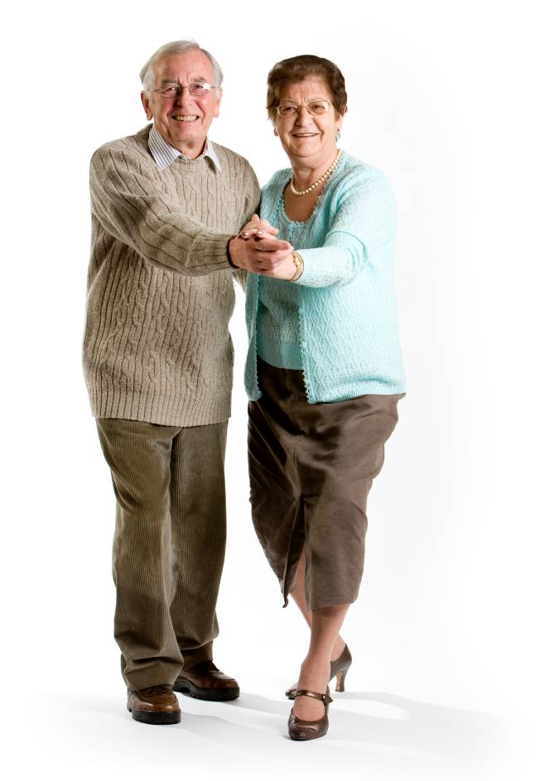
Welcome to your personal Fitness MOT. Students and staff at Glasgow Caledonian University will take you through a variety of tests that will give you an indication of your exercise performance. Each test comes with a set of “normal values” for people of different ages and this will give you an idea of whether you are “doing well” compared to your peers, or whether you could benefit from being more active. The end of this pack will give you some local activity opportunities that you might like to join in with and some “online” websites that will give you some more information.

Name: _______________________________________

Date: ________________________________________

Weight: ______________ kg (___________st _____lbs)

Height: ______________ m (___________ft _____ins)
We will record your ability on each of the following tests and compare your results to others of the same age and gender as you. Each graph has two grey lines on it – these are the upper and lower limits of “normal” across the age range 60-95 years. If your score (marked with an X on the graph) is within the two grey lines then you are in the normal range for that test for your age. If your X is below these two lines then your performance is below average and if your X is above the two lines then your performance is above average. You may have a medical condition or other reason for your performance not being average and we encourage you to tell the person doing this test with you if this is the case.

Normal Data References:
- Rikli RE and Jones CJ (1999) Functional fitness normative scores for community-residing older adults aged 60-94. Journal of Aging and Physical Activity, Vol.7: pp162-181.
- Skelton DA, Greig C, Davies JM, Young A. (1994) Strength, power and related functional ability of healthy people aged 65-89 years. Age and Ageing, Vol.23: pp371-377.
- El Sobkey SB et al. (2011). Normative values of one leg stance in community dwelling older people. MEJSR, Vol.7: pp497-503.

30 Second Chair Stand
The 30-second chair stand measures lower limb strength, which is needed to climb stairs, walk distances, get out of a chair, bathtub or car, and rise from lying down. Lower body strength also helps reduce the risk of balance problems and falls. The test is normally performed with your arms folded.

Your Test Result: _______ Stands - Arms folded?: Yes/No

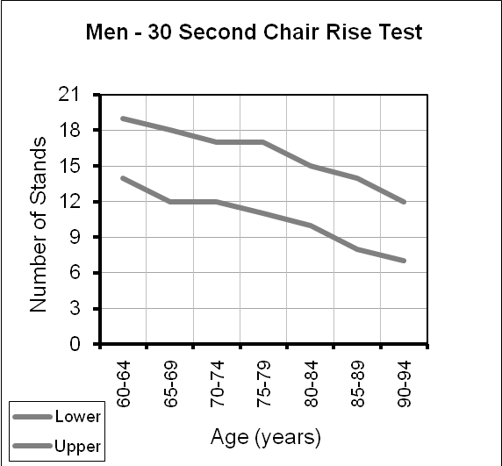
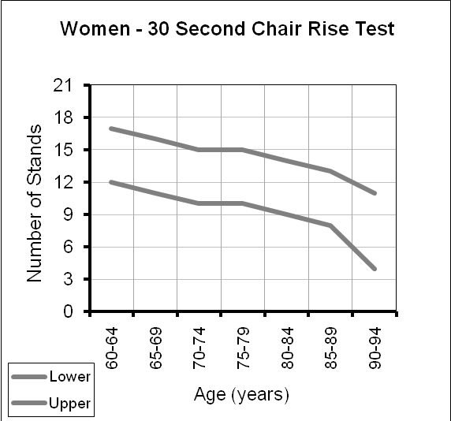

Chair Sit and Reach
The chair sit-and-reach is an overall measure of lower-body flexibility, which is important for posture and for mobility tasks like walking and climbing stairs. Lower flexibility can also help prevent lower-back pain and Musculoskeletal injuries.

Your Test Result: _______ Cm

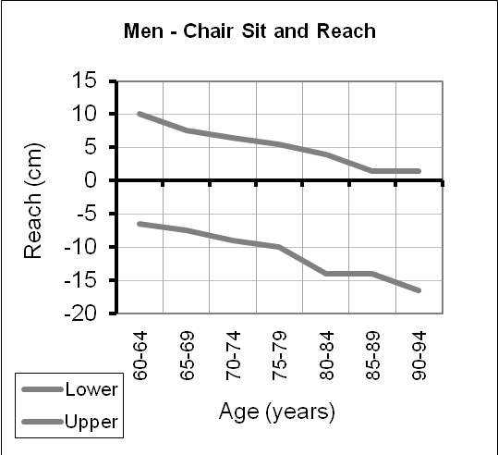
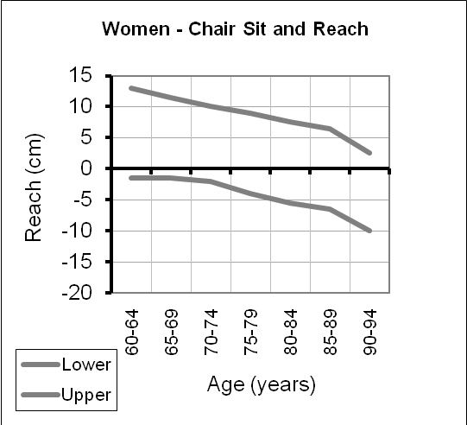

Back Scratch
The back scratch measures upper-body shoulder flexibility, which is necessary for several everyday tasks, such as combing or washing your hair, zipping a dress, putting on an over-the-head garment or reaching for a seat belt. Keeping the shoulders flexible also helps reduce pain and stiffness.

Your Test Result: _______ Cm

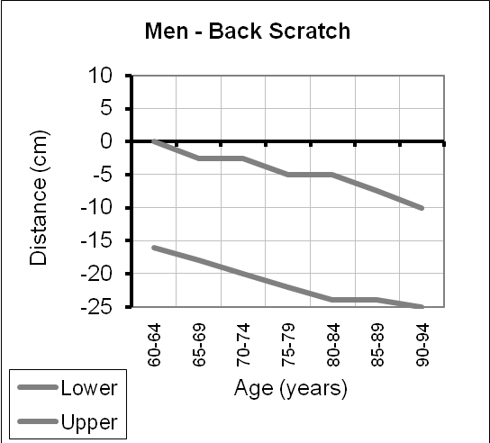
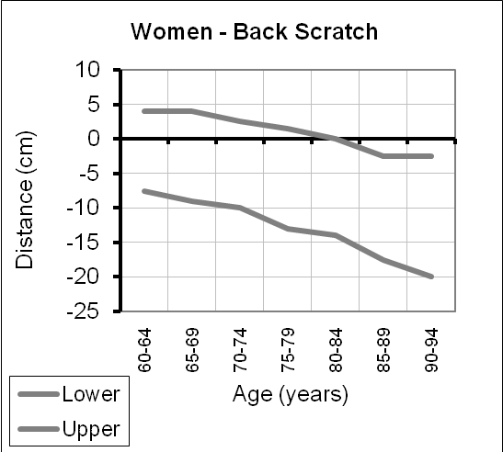

8 Foot Up and Go
The 8 foot timed up-and-go measures both motor ability and dynamic balance, which are important for a number of common mobility tasks, such as recovering after tripping, manoeuvring in a crowd, being able to walk across the street before the signal lights turns red and a variety of recreational and sports activities.

Your Test Result: _______ Secs - Use of walking aid? Yes/No

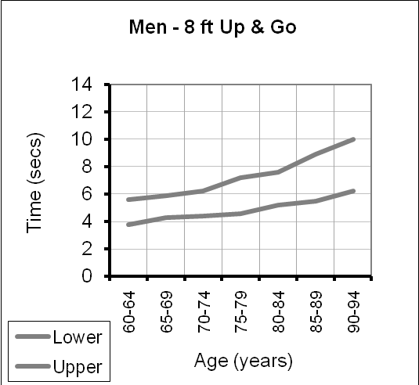
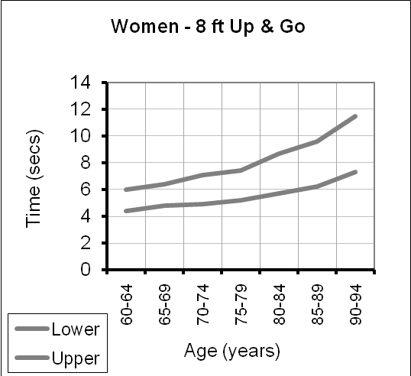

Handgrip Strength
You need good handgrip strength to be able to hold on tight on the bus, open jars and taps and of course, carry heavy shopping bags.

Your Test Result: _______ Kg Hand used:________

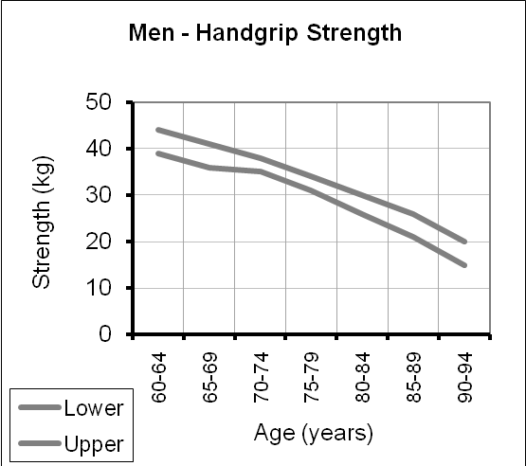
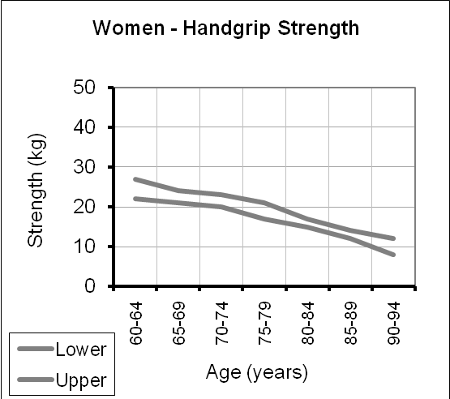

Single Leg Stance
Balance is important so that you can correct a trip, reach for things in tall cupboards and generally maintain independence.

Your Test Result: _______ Secs Leg Used:________

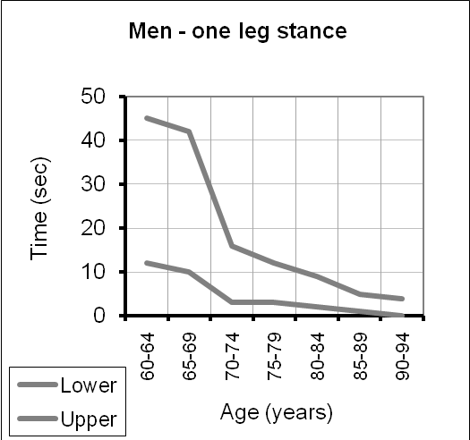
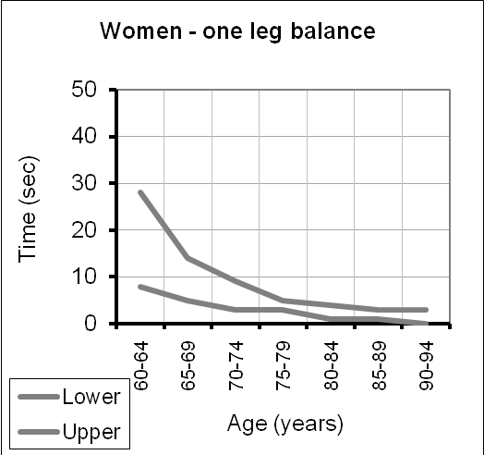

6 Min Walk
The six-minute walk measures aerobic endurance, which is needed to perform a variety of activities, including walking, shopping, sightseeing on vacations, completing household chores and participating in sports and recreational activities without undue fatigue.

Your Test Result: _______ Meters. Needed a rest mid walk? Yes/No
Use of walking aid? Yes/No

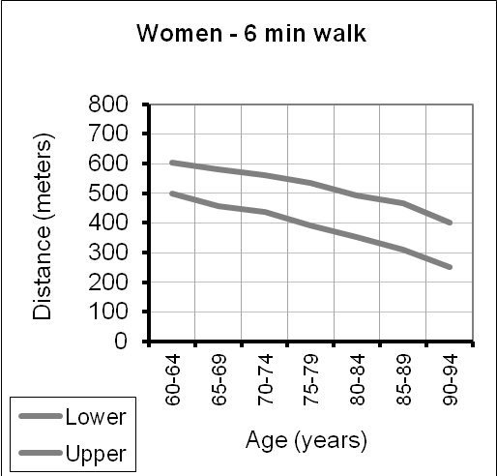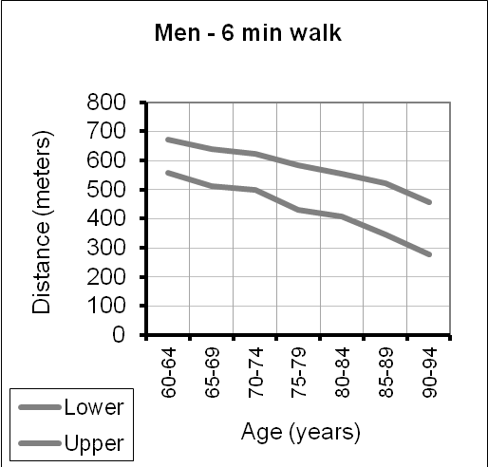

Physical Activity
This scale gives an indication of your self reported activity in a normal week.

In a normal week (weather permitting) how often do you:

Walk for more than half an hour in one go?:______________________________
Do you get warmer or breathe slightly more heavily? Yes / No

Play any sporting activities (bowls, tennis etc)?: ___________________________
Do you get warmer or breathe slightly more heavily? Yes / No

Attend an exercise class?: _____________________________________________
Do you get warmer or breathe slightly more heavily? Yes / No

Attend a gym?:______________________________________________________
Do you get warmer or breathe slightly more heavily? Yes / No

Swim?:_____________________________________________________________
Do you get warmer or breathe slightly more heavily? Yes / No

Dance?:____________________________________________________________
Do you get warmer or breathe slightly more heavily? Yes / No

Do exercise at home (from a booklet or DVD)?:____________________________
Do you get warmer or breathe slightly more heavily? Yes / No

Do any other leisure activities that make your heart beat faster? ______________
Do any other activities that leave your muscles a bit achy the next day?_________
Do any other activities that you have to concentrate to keep your balance?______
Do you spend more than 2 hours at a time sitting during the day? _____________

Physical Activity Guidelines for Older People state that for maintenance of health and independence, older people should:

- Do activities that leave them slightly warmer or make them breath slightly harder than normal for at least 150 minutes (could be 5 x 30 mins, or in shorter more regular bouts) a week
- Do activities that challenge and help improve their strength at least twice a week
- Do activities that challenge and help improve their balance at least twice a week
- Do activities that help maintain or improve their range of movement (flexibility) daily
Do you meet these guidelines? If not, we will talk through options that might help you increase your activity. This includes considering any medical conditions you may have that might mean we suggest certain activities over others. If there are any components of fitness where your test results are below the average of your peers, we will suggest activities to improve these. When working out and action plan it is always best to try to set short term achievable goals.

Action plan to try to improve your fitness:

1.
2.
3.
4.
5.

Useful information about physical activity and exercise
locally and online

Local Information
Glasgow Life run classes, sporting activities and walking groups across and around Glasgow. Contact Glasgow Life on 0141 287 9882

Or read about their Vitality Classes at http://www.glasgowlife.org.uk/sport/fitness-classes/vitality/Pages/home.aspx
Or their walking opportunities at
http://www.glasgowlife.org.uk/sport/outdoor-activities/walking/Pages/home.aspx
Or Silver Deal activities at http://www.glasgowlife.org.uk/silverdealactive

Paths for Health offer many guided walking activities in and around Glasgow. Contact Paths for Health on 0141 287 0963
Or visit their online site at http://www.pathsforall.org.uk/find-a-health-walk/glasgow-city/walk-glasgow.html

Or visit your local gym or fitness centre and see what activities they can offer.

Online

Balance Training online – this site allows you to read advice about what activities improve your balance
http://www.balancetraining.org.uk/fallsAdvice/index.jsp

Fitness Videos, Home Exercise Booklets and Advice
http://www.ageuk.org.uk/health-wellbeing/keeping-fit/exercise-materials/
http://www.laterlifetraining.co.uk/category/resources-for-older-people/

Local Falls Service
The Community Falls Prevention Service offers a home visit for advice on prevention of future falls and if appropriate referral to their specific falls prevention exercise sessions. To find out more call 0141 427 8311

With thanks to:



