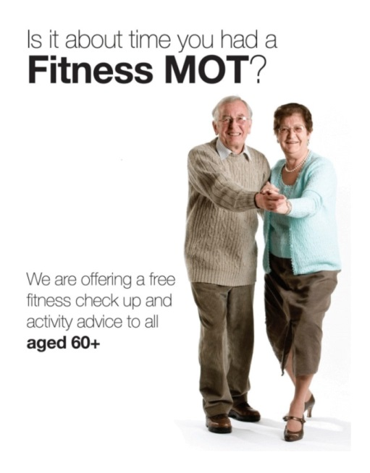
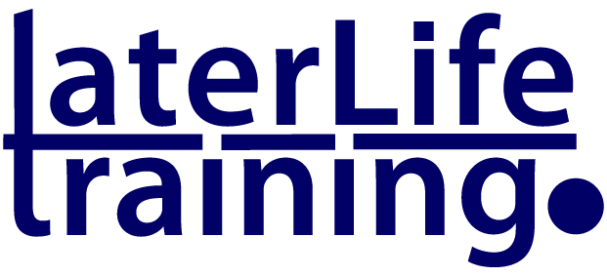
TRAINING OPPORTUNITY

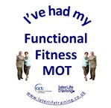
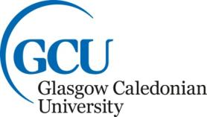

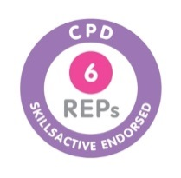

The Functional Fitness MOT

This innovative and person centred assessment activity was designed at Glasgow Caledonian University to highlight the different components of fitness (as recognised in the 2011 UK CMO Guidelines for Older Adults) necessary for older people to maintain independent living, physical and mental health. The Functional Fitness MOT results can be used with an older person to highlight their individual strengths and weaknesses and the next steps required to initiate physical activity participation. This is followed by discussion around the person’s needs, preferences and motivation to take advantage of local opportunities and activities designed to promote active ageing.
Later Life Training provide a series of training days designed to assist Active Ageing professionals to understand how they can use the Functional Fitness MOT with the groups and individuals they work with.
Coming to your area

More details of the Functional Fitness MOT can be found at
http://www.laterlifetraining.co.uk/functional-fitness-mots-for-awareness-raising/
For details of how to book a place - go to
http://www.laterlifetraining.co.uk/courses/fully-functional-mot/functional-fitness-mot-course-dates/
