Personal Fitness MOT

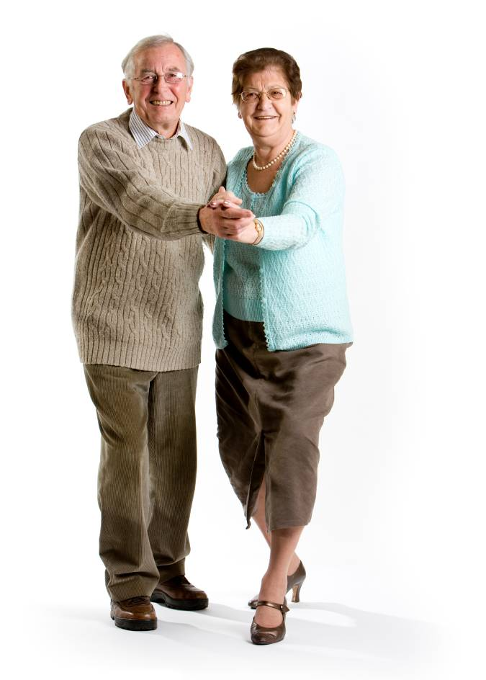
Welcome to your personal Fitness MOT. Students and staff at Glasgow Caledonian University will take you through a variety of tests that will give you an indication of your exercise performance. Each test comes with a set of “normal values” for people of different ages and this will give you an idea of whether you are “doing well” compared to your peers, or whether you could benefit from being more active. The end of this pack will give you some local activity opportunities that you might like to join in with and some “online” websites that will give you some more information.

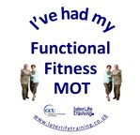
Name: ___________________________________

Date: ____________________________________

Weight: ____________ kg (_________st _____lbs)

Height: ____________ m (_________ft _____ins)
Welcome to your Functional Fitness MOT. These everyday activity tests allow you to compare your performance with others of the same age and gender. You may have a medical condition or other reason for your performance not being average and we encourage you to tell the person doing this test with you if this is the case.

Today, we recorded your ability on each of the following tests and marked your result on the graph (men or women) and wrote your result above the graph.

Interpreting the graphs/test results:
Each graph has two grey lines on it – these are the upper and lower limits of “normal” across the age range 60-95 years. If your score (marked with an X) is within the two grey lines then you are in the normal range for that test for your age and gender. If your X is below these two lines then your performance is below average and if your X is above the two lines then your performance is above average.

Example: If you were aged 77 and female, and managed 12 sit to stands in 30 seconds, you would be in the ‘normal’ range for your age (X).

Your Test Result: _12____ Stands Arms folded?: Yes/No

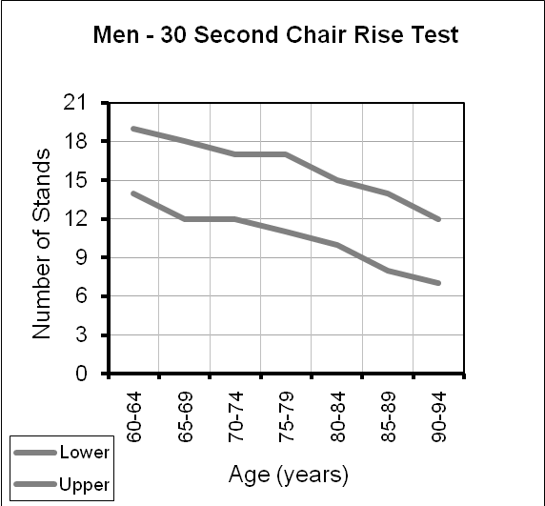
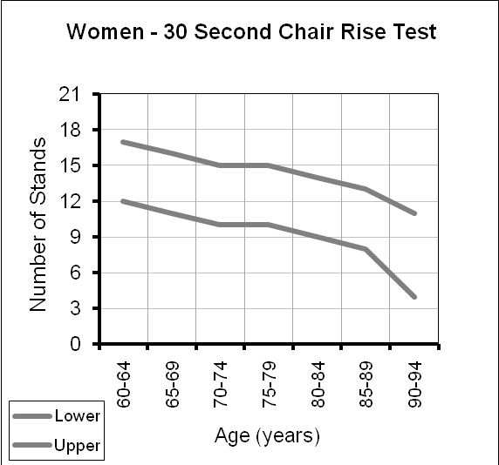
X

30 Second Chair Rise
The 30-second chair stand measures lower limb strength, which is needed to climb stairs, walk distances, get out of a chair, bathtub or car, and rise from the floor. Lower body strength also helps reduce the risk of balance problems and falls. The test is normally performed with your arms folded.

Your Test Result: _______ Stands Arms folded?: Yes/No

Chair Sit & Reach
The chair sit-and-reach is an overall measure of lower-body flexibility, which is important for posture and for mobility tasks like walking and climbing stairs. Lower-body flexibility can also help prevent lower-back pain and musculoskeletal injuries. A minus (-) score means you could not reach your toes, a plus (+) score means you reached past your toes.

Your Test Result: _______ Cm

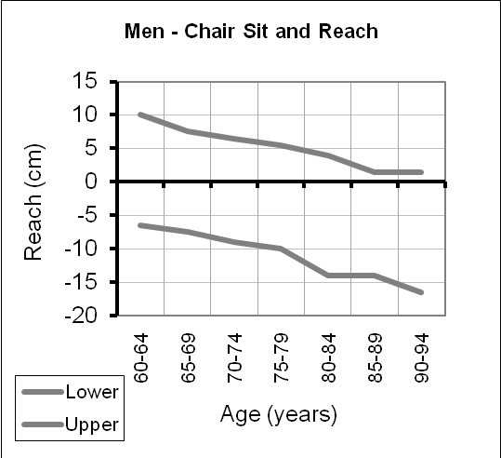
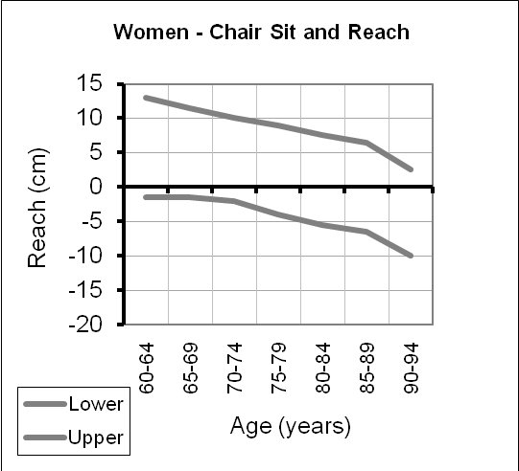

Back Scratch
The back scratch measures upper-body shoulder flexibility, which is necessary for several everyday tasks, such as combing or washing your hair, zipping a dress, putting on an over-the-head garment or reaching for a seat belt. Keeping the shoulders flexible also helps reduce pain and stiffness. A minus (-) score means you could not touch the fingers of both hands, a plus (+) score means you overlapped your hands.

Your Test Result: _______ Cm

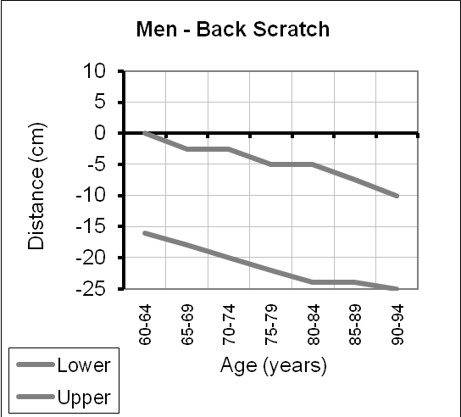
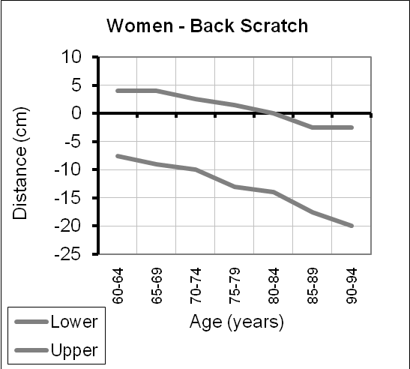

8 Foot Timed Up & Go
The 8 foot timed up-and-go measures both motor ability and dynamic balance, which are important for a number of common mobility tasks, such as recovering after tripping, manoeuvring in a crowd, being able to walk across the street before the signal lights turns red and a variety of recreational and sports activities.

Your Test Result: _______ Secs Use of arms to get out of chair? Yes/No
Use of walking aid? Yes/No

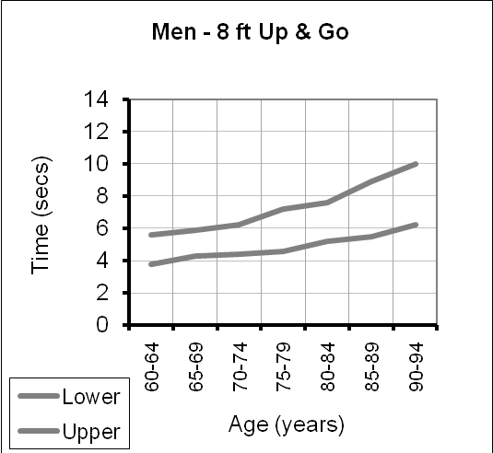
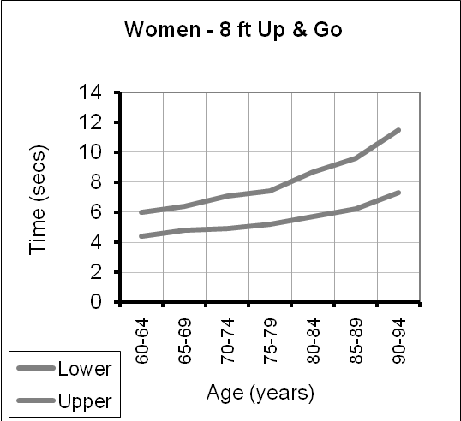

One Leg Balance
Balance is important so that you can correct a trip, reach for things in tall cupboards and generally maintain independence.

Your Test Result: _______ Secs Leg Used: Left/Right

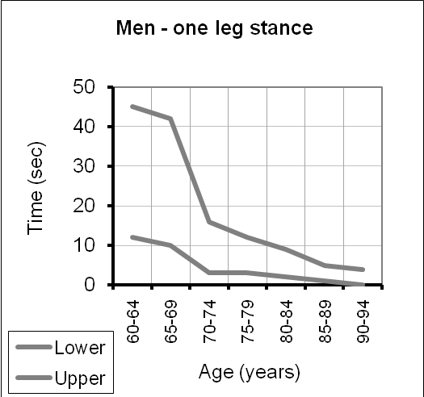
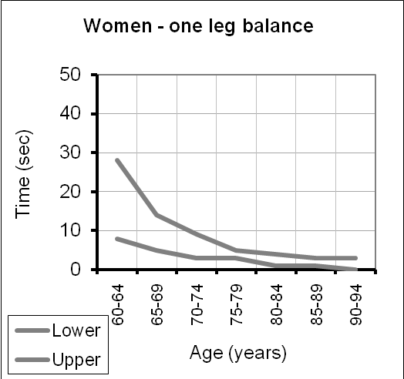

Handgrip Strength
You need good handgrip strength to be able to hold on tight on the bus, open jars and taps and of course, carry heavy shopping bags.

Your Test Result: _______ Kg Hand used: Left/Right

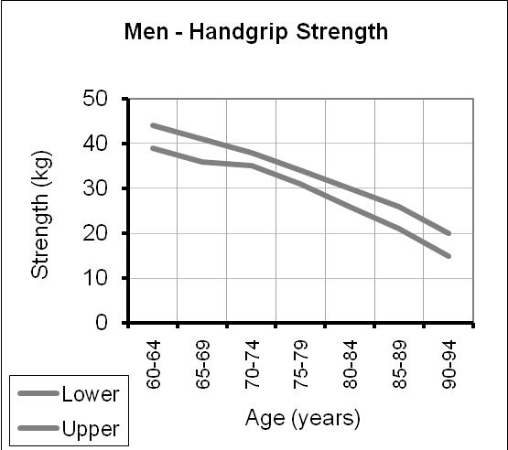
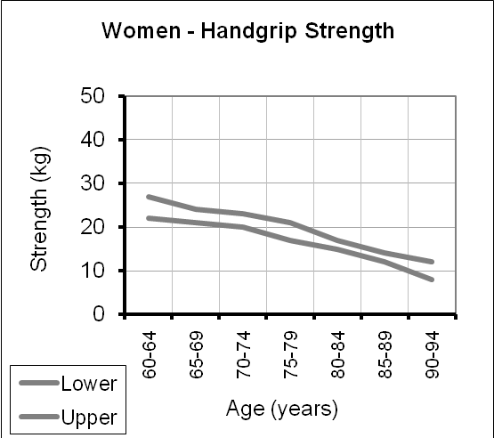

6 Minute Walk
The six-minute walk measures aerobic endurance, which is needed to perform a variety of activities, including walking, shopping, sightseeing on vacations, completing household chores and participating in sports and recreational activities without undue fatigue.

Your Test Result: _______ Meters. Needed a rest mid walk? Yes/No
Use of walking aid? Yes/No

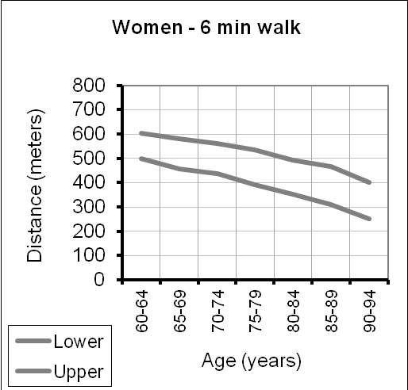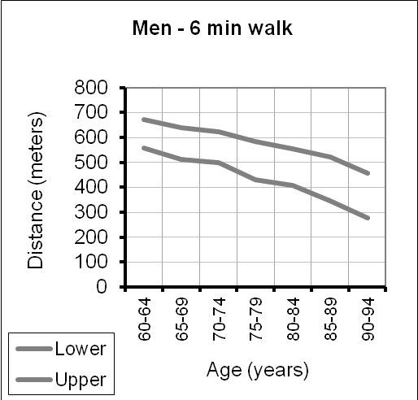

Physical Activity Guidelines for Health

Physical Activity Guidelines for Older People (Chief Medical Officer) recommend that for maintenance of health and independence, older people should:

- Reduce the amount of time sitting for long periods (or break up long periods of sitting as often as possible)
- Do activities that help improve their strength at least twice a week (activities that make the muscles warmer or even shaky and you may ‘feel’ the muscles used the next day or day after)
- Do activities that challenge and help improve their balance at least twice a week (activities that make you feel a bit ‘wobbly’ or that you have to concentrate on maintaining your balance)
- Do activities that leave them slightly warmer or make them breathe slightly harder than normal for at least 150 minutes a week (in bouts of 10 mins or more and regular throughout the week)

These questions below give an indication of your physical activity.

What proportion of your day do you spend sitting? Please mark on the line below.
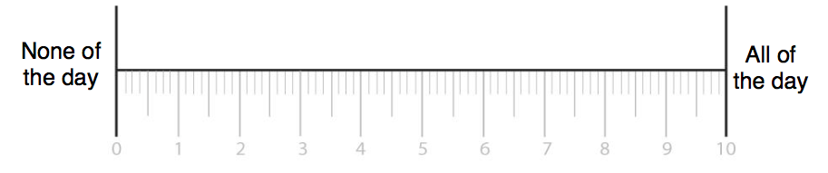
Do you sit for more than 2 hours at a time during the day? __________________

In a normal week (weather permitting) how often do you:

Walk for more than half an hour in one go?:______________________________
Do you get warmer or breathe slightly more heavily? Yes / No

Play any sporting activities (bowls, tennis, golf, etc)?: ______________________
Do you get warmer or breathe slightly more heavily? Yes / No

Attend an exercise class or a gym?: _____________________________________
Do you get warmer or breathe slightly more heavily? Yes / No
Do you do activities that strengthen muscles or challenge balance? Yes / No

Swim?:_____________________________________________________________
Do you get warmer or breathe slightly more heavily? Yes / No

Dance?:____________________________________________________________
Do you get warmer or breathe slightly more heavily? Yes / No

Do exercise at home (from a booklet or DVD)?:____________________________
Do you get warmer or breathe slightly more heavily? Yes / No
Are these exercises aimed at improving strength and/or balance? Yes / No

Do any other leisure activities that make your heart beat faster? ______________

Do any other activities that leave your muscles a bit achy the next day?_________

Do any other activities that you have to concentrate to keep your balance? _____

Do you meet these guidelines?

If you do, that's good and your test results in the Functional Fitness MOT will reflect this.

If not, we will talk through options that might help you increase your activity. This includes considering any medical conditions you may have that might mean we suggest certain activities over others. If there are any components of fitness where your test results are below the average of your peers, we will suggest activities to improve these. When working out an action plan it is always best to try to set short term achievable goals that help you in the longer term make activity a habit.

Action plan to try to improve your fitness:

1.
2.
3.
4.
5.

Useful information about physical activity and exercise
locally and online

Local Information
Glasgow Life run classes, sporting activities and walking groups across and around Glasgow. Contact Glasgow Life on 0141 287 9882

Or read about their Vitality Classes at http://www.glasgowlife.org.uk/communities/goodmove/vitality/pages/default.aspx
Or other Glasgow Life opportunities that might be of interest to you –
http://events.glasgowlife.org.uk/search?Audience=adults&srt=date

Paths for All offer many guided walking activities in and around Glasgow. Contact Paths for Health on 0141 287 0963
Or visit their online site at http://www.pathsforall.org.uk/find-a-health-walk/glasgow-city/walk-glasgow.html

Or visit your local gym or fitness centre and see what activities they can offer.

Online

Find other physical activity opportunities for you across Scotland - http://www.activescotland.org.uk
Balance Training online – this site allows you to read advice about what activities improve your balance - https://fallsassistant.org.uk/exercise-centre/

Fitness Videos, Home Exercise Booklets and Advice
http://www.ageuk.org.uk/health-wellbeing/keeping-fit/exercise-materials/
http://www.laterlifetraining.co.uk/category/resources-for-older-people/

Local Falls Service
The Community Falls Prevention Service offers a home visit for advice on prevention of future falls and if appropriate referral to their specific falls prevention exercise sessions. To find out more call 0141 427 8311. Alternatively you can go online to https://fallsassistant.org.uk and look at the advice there.

Normal Data References:
- Rikli RE and Jones CJ (1999) Functional fitness normative scores for community-residing older adults aged 60-94. Journal of Aging and Physical Activity, Vol.7: pp162-181.
- Skelton DA, Greig C, Davies JM, Young A. (1994) Strength, power and related functional ability of healthy people aged 65-89 years. Age and Ageing, Vol.23: pp371-377.
- El Sobkey SB et al. (2011). Normative values of one leg stance in community dwelling older people. MEJSR, Vol.7: pp497-503.

